MtoM & YtoY tooset helper manual

# Fill in user scenario info - **1_Scenarios.py**

## Example command

We have 2 formal scenario info source files: **month.xlsx** and **scenario.xlsx**.

This step picks the scenario info from the 2 excel files and fills in them in target monthly data file (2024-02-10) missed grids, so it cannot resolve all blank grids when the 2 source file also have no corresponding info.

python 1_Scenarios.py --f1 month.xlsx --s1 Sheet1 --f2 scenario.xlsx --s2 Customers --f3 2024-02-10K.xlsx --s3 Export

## Explain the arguments:

1. First step, you should install the python packages by pip:

pandas

argparse

1. The arguments:

--f1 : month.xlsx

--s1 : Sheet1

--f2 : scenario.xlsx

--s2 : Customers

--f3 : 2024-02-10.xlsx ()

--s3 : Export

1. The output:

out_2024-02-10K.xlsx

## Packaged commands in bat file:

File:

1_Scenarios_batch.bat

Content:

python 1_Scenarios.py --f1 month.xlsx --s1 Sheet1 --f2 scenario.xlsx --s2 Customers --f3 2024-2.xlsx --s3 Export

python 1_Scenarios.py --f1 month.xlsx --s1 Sheet1 --f2 scenario.xlsx --s2 Customers --f3 2024-3.xlsx --s3 Export

python 1_Scenarios.py --f1 month.xlsx --s1 Sheet1 --f2 scenario.xlsx --s2 Customers --f3 2023-3.xlsx --s3 Export

# Transfer month data to summaries : **2_GetMMYYFrom10KScenariosV3_Thomas.py**

## Argument lines

Because there 9 option variables, they are not placed with command arguments. Please modify them with the real status.

## Please use the output file of 1st step as source file.

## The output files should be this:

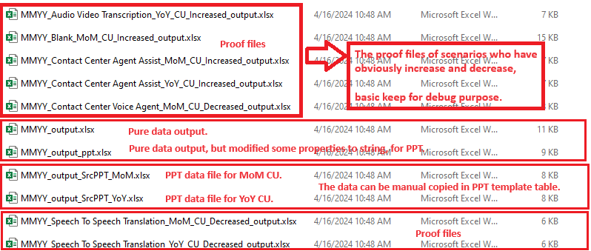

# Convert PPT data file to ppt : **3_ConvertToPPTX.py**

## Example command

After step 2, now we have 2 output ppt data files:

**MMYY_output_SrcPPT_MoM.xlsx**

**MMYY_output_SrcPPT_YoY.xlsx**

This step read the output files and convert them into PPTX file, so that you can then copy the created PPTX pages in target ppt report directly.

python 3_ConvertToPPTX.py --f **MMYY_output_SrcPPT_MoM.xlsx** --s Sheet1

python 3_ConvertToPPTX.py --f **MMYY_output_SrcPPT_YoY.xlsx** --s Sheet1

## Explain the arguments:

1. First step, you should install the python packages by pip:

pandas

argparse

pptx

1. The outputs:



